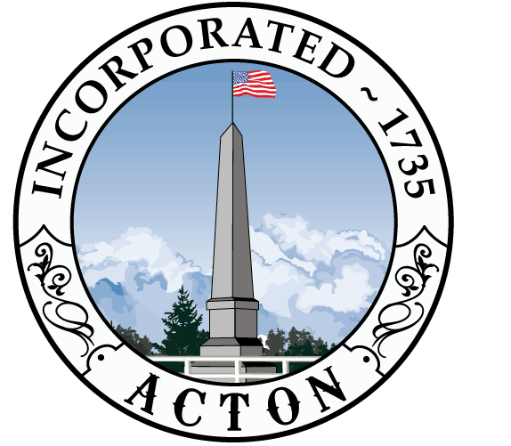
Acton 2020 Committee
Agenda
February 13, 2013 – 7:00 PM
Acton Town Hall, Room 204

- Approve minutes from 1/16/03 and 1/30/13 (5 min)

- Hear from Morrison Farm Committee--Bill Mullin (30 min)

- Committee membership/outreach (5 min)

- Website update(15 min)

- Debrief DRB and ALG on Kelley’s Corner capital request (30 min)

- Discuss preparation for Kelley’s Corner outreach (60 min)
  - Review documents—Neighborhood mailer, town-wide mailer, FAQs, letter to business owners
  - Review preliminary materials from Cecil Group re: public meetings
  - Agree on other committee outreach (BoS, Sidewalk committee, FinCom)
  - Devise social media strategy
  - Agree on method for tracking contacts (e.g., Kat is keeping track of business KC stakeholders)

