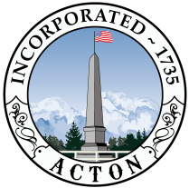
ACTON ZONING BOARD OF APPEALS
Tuesday November 12, 2024
7:30 PM
Virtual Meeting

To Participate Remotely:
From a computer, please click on the link below to join the public meeting
Webinar: https://zoom.us/j/554165889
Or
From a telephone, dial (646) 876 9923 and enter Webinar ID: 554 165 889#
Telephone users may dial *9 to request to speak after joining the meeting. Computer and app users may use the “raise hand” feature to request to speak.

- Regular Business
- Approve previous meeting minutes
- Administrative Updates

- New/Special Business

- 7:35PM --ZBA24-02- Public Hearing – 37-39 Nagog Hill Road, Special Permit

Additional materials can be found here: https://doc.actonma.gov/dsweb/View/Collection-17690

The listed agenda items are those reasonably anticipated by the Chair. Not all items may in fact be discussed and other items not listed may also be brought up for discussion to the extent permitted by law. Reasonable accommodations for people with disabilities are available upon request. Include a description of the accommodation you will need, including as much detail as you can and include a way we can contact you if we need more information. Please allow advance notice. Send an e-mail to planning@actonma.gov or call the Planning Division’s Office (978)929-6631

For more information about Zoning Board of Appeals contact
ZBA@actonma.gov or 978-929-6631

